Press Release

12% decline in the Shower market due to impact of Covid-19

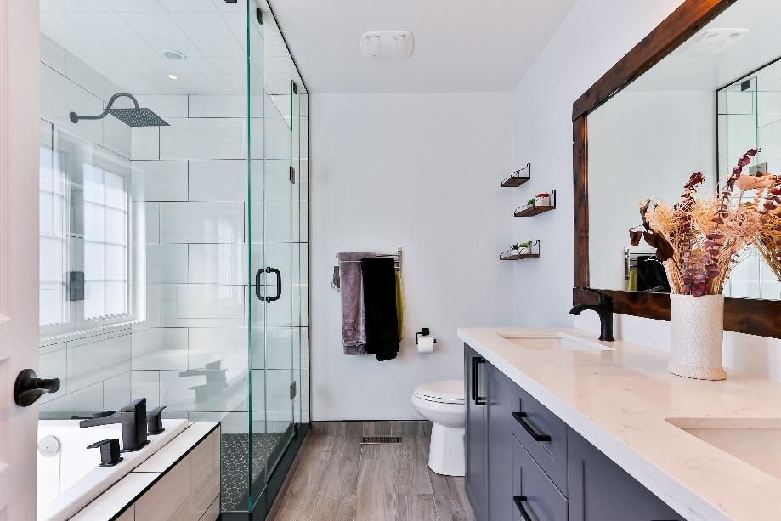

In 2020, the UK shower equipment market was impacted by the start of the Covid-19 pandemic and saw a sharp decline in value of around -12%. Over recent years this market has benefitted from the increasing preference towards showering, technological developments, and the growing demand for more premium solutions.
In 2020, around 93% of UK households have at least one shower installation in their property. Around two thirds of shower controls tend to be installed over a bath, however a significant number of households also have a secondary separate shower facility, e.g., shower enclosure or wetroom area.
Abdul Tantouch, Market Researcher at AMA Research comments “the shower market has now reached maturity in the UK, with a significant and ongoing demand for more premium solutions. Flexibility, convenience, and ease of use are key requirements and are influencing the shift towards higher value products. Given the current levels of uncertainty because of the Covid-19 pandemic and Brexit, durability and longevity are also important attributes. It is increasingly important for suppliers to deliver quality and variety in their product offerings to justify homeowner investment. “
With the Covid-19 pandemic there has been a significant increase in the level of online purchases, particularly during lockdown periods. This trend is expected to continue with the internet has raising expectations and awareness of affordable design-led products. There is potential for the shower equipment market to rebound after mid-2021, with demand particularly emulating from homeowners that have accumulated savings over the past year.
Shower products for both the residential and commercial sectors are distributed through a wide range of channels. The main distribution channel continues to be merchants with home improvement multiples also holding a substantial share. Other retail channels include bathroom specialists, online retailers, retail multiples and department stores. Manufacturers are also selling spare parts and accessories direct to the consumer online, via transactional websites.
In 2021 it is estimated that the market will decline by a further -2%, followed by more steady growth of 3-4% per annum from 2022 to 2025. The wide availability of Covid-19 vaccines and a more certain UK economy will support confidence levels going forward, with possible pent-up demand driving sales.

Editors Note:
The information was taken from the Shower Market Report – UK 2021-2025 by AMA Research, which is available to purchase now at www.amaresearch.co.uk or by calling 01242 235724.
Please include our web address on any press release or article published. If you would like to receive more information on the report, or would like to speak to the Editor, then please contact:
Roshni Cornock
AMA Research
t: +44 (0) 1242 235724
e: roshnipatel@amaresearch.co.uk

About AMA Research
AMA Research is a leading provider of market research and consultancy services with over 30 years’ experience within the construction and home improvement markets. For more information, go to www.amaresearch.co.uk or follow us on Twitter @AMAResearch for all the latest building and construction market news.
Since 2017, AMA Research has been part of Barbour ABI, a leading provider of construction intelligence services. Barbour ABI is part of UBM, which in June 2018 combined with Informa PLC to become a leading B2B information services group and the largest B2B Events organiser in the world. To learn more and for the latest news and information, visit www.ubm.com and www.informa.com.

